GTAFE Electric Automotive Mechanic V1.2.2
User and Customer Support Guide

Shenzhen GTA Education Tech Ltd.
All rights reserved

Table of Contents
- Introduction 3
1.1. Objective 3
1.2. Background 3
1.3. Definition 3
1.4. References 3
2. Purpose 3
2.1. Functional Features 3
2.2. Performance Features 4
Uninvolved 4
3. Runtime Environment 4
3.1. Hardware Environment 4
3.2. Software Environment 5
4. Operating Procedures 5
4.1. Installation and Initialization 5
4.1.1. Client Installation 5
4.2. Operation Description 9
4.2.1. Client login 9
4.2.2. Main interface 9
4.2.3. Components 11
4.2.4. Training of Whole Vehicle 20
5. Application notes 34
6. Appendix 35

Introduction

Objective
This manual is the user and customer support guide, intended to providing installation and operating guidance for users of GTAFE Electric Automotive Mechanic V1.2.2. Users mainly include students and teachers related to new energy automobiles in secondary and higher vocational schools, colleges, and universities.

Background
Proposed by the VR Department, the software is developed by the VR Product R&D Center. Its clients cover secondary and higher vocational schools, colleges, and universities.

Definition
Term | Definition or description
3D | Digital three dimensional / stereoscopic technology based on computer
Virtual Disassembly and Assembly | Product disassembly and assembly based on virtual reality
VR | Virtual reality

References
GTAFE Electric Automotive Mechanic V1.2.2 - Installation and Deployment Manual
GTAFE Electric Automotive Mechanic V1.2.2 - Customer Requirements List

Purpose

Functional Features
1 | Functional Requirement | UI adjustment | UI involved in text change is adjusted in design.

Performance Features

Uninvolved

Runtime Environment

Hardware Environment
Parameter | Description |  | Specifications
Hardware Configuration | Monitor | - 24-inch, resolution: 1920 x 1080; supporting 2D and 3D  - Brightness: 2D ≥ 250cd / m2 ; 3D ≥ 150cd / m2, Horizontal visual angle ≥ 170°, Vertical visual angle ≥ 160°  - Contrast: 800 : 1 or above; Color ≥ 16700000  - Pixel defect: ≤ 7.
 | Capture Locator | Equipped in the monitor, the locator can achieve a 3D effect and localization by means of 3D glasses.  Available capture range: 1.2m in length, 1.5m in width, and 1m in height based on the center of the motor
 | Tracking 3D Glasses | The 3D glasses can be used to view the 3D scenario. There are five tracking points, so that the capture locator can accurately achieve a 3D effect and localization. A set of tracking 3D glasses includes complete tracking glasses and legless tracking Clip-ons.
 | Stylus | It can move, rotate and split the objects in the 3D scenario. It offers movement and rotation data in 3 degrees of freedom coordinate axes, and the related resolution, accuracy and refresh rate are required as follows:  3D axial resolution: X axis ≤2mm, Y axis ≤2mm, Z axis ≤ 2mm.  Accuracy: spacing accuracy ≤ 2deg, swing accuracy ≤2deg, deflection accuracy ≤2deg.  3D axial accuracy: X axis≤+/-3mm, Y axis≤+/-3mm, Z axis≤+/-3mm.  3D axial refresh rate: X axis ≥ 100Hz, Y axis ≥ 100Hz, Z axis ≥ 100 Hz.
 | Port | Display Port (1.2): ≥1; DVI port: ≥1; positioning processing unit interface

Software Environment
Windows 10 and zSpace software

Operating Procedures

Installation and Initialization

Client Installation
- Double click on the setup program to enter the installation interface as shown below.
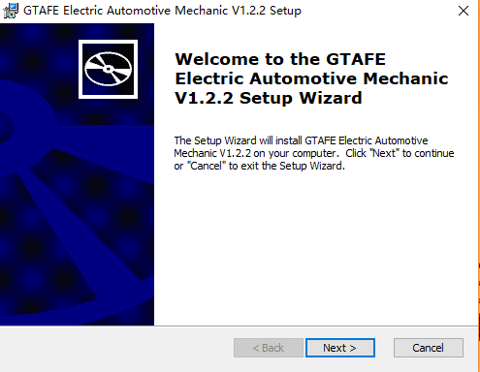
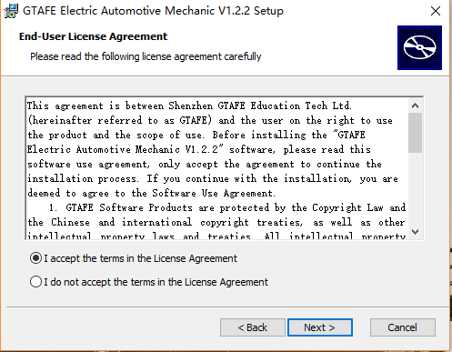
- Click on “Next”, and then click on “Browse” to select a new directory, otherwise the default directory will be used.
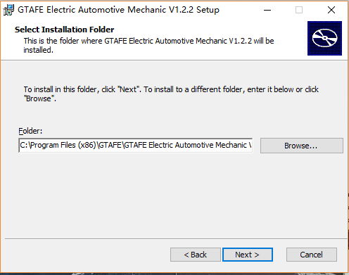
- Click on “Next” to prepare for the installation.
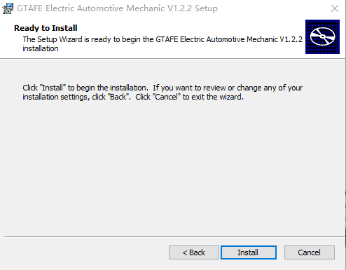
- Click on “Install” to start the installation and configuration.
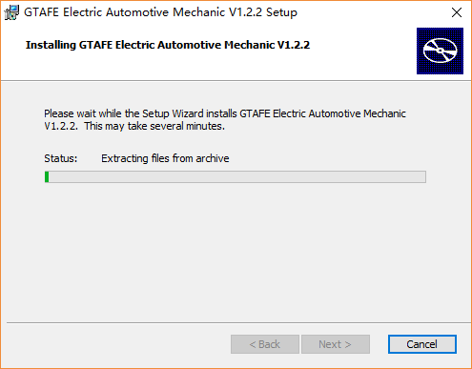
- Click on “Finish” to exit.
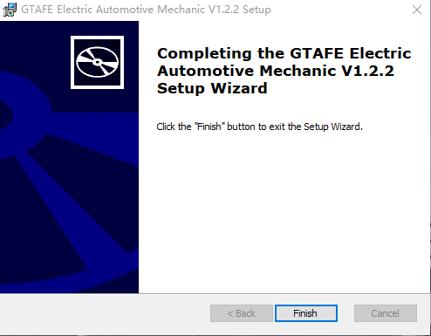

Operation Description

Client login
Launch the client and enter the registration interface. Fill in the registration code and authorization code obtained through the application code, and then click on ‘Activate
License’ to start using the software.
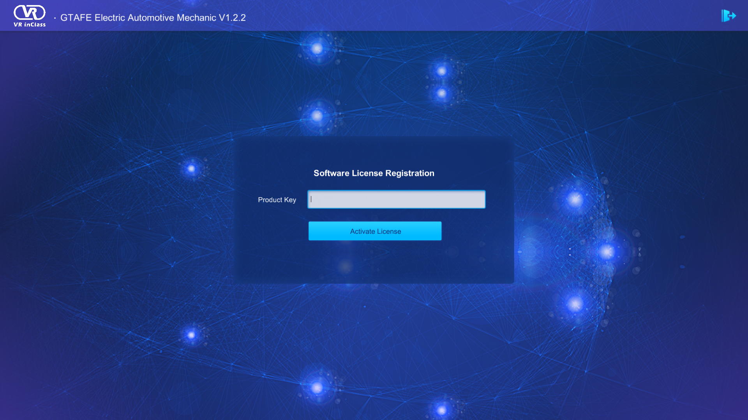
License Registration Interface

Main interface
After the license is activated, user will enter the main interface. There are two buttons: Components and Training of Whole Vehicle. The default is Components, corresponding to the function modules of the components. User can click on ‘Training of Whole Vehicle’ to switch to the function modules of the training of whole vehicle. On the right, there are three buttons: Naked Eye 3D, zView, and Settings. User can click on the Exit button on the lower-right corner of the interface to exit the software. Click on the Guide button to play the guide animation.

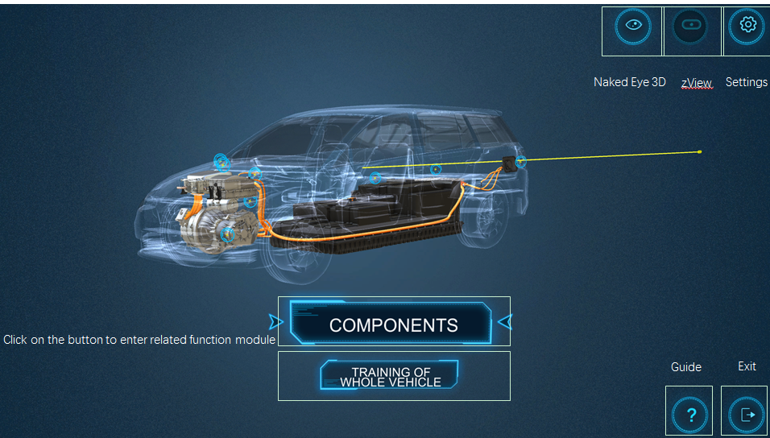
Main interface
Users can set their own pupillary distance and ray length in the ‘Settings’ interface.
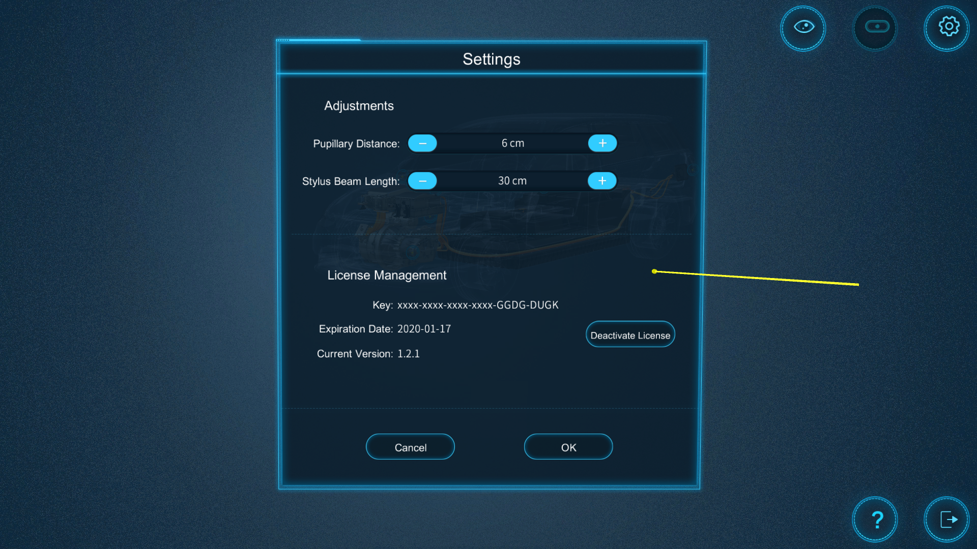
Settings Interface

Components
After user enters the main interface, the default is the function interface of the Components. In the center, it is the vehicle model with a transparent shell. Its internal components include Powertrain, Power battery, High voltage cable, High voltage distribution box, Charging port, Motor controller, DC/DC, and Electric air conditioner compressor. When the ray is moved over a corresponding component, the label of hint will pop up, and the selected component will be highlighted in yellow.

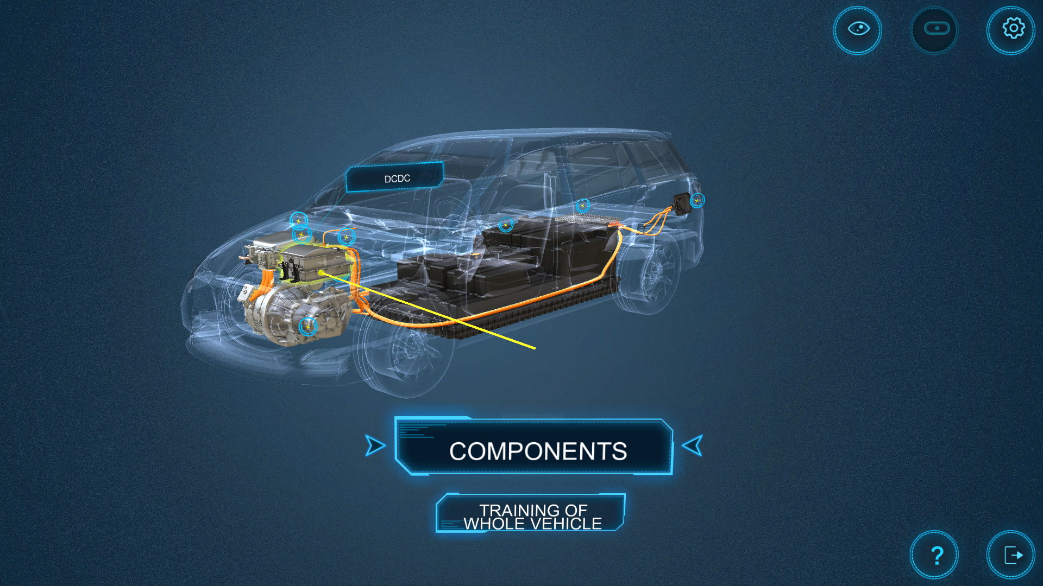

Label of Hint
After selecting a part, press the middle button of the stylus to select and enter the corresponding modules, and then the selected part will be highlighted in green.
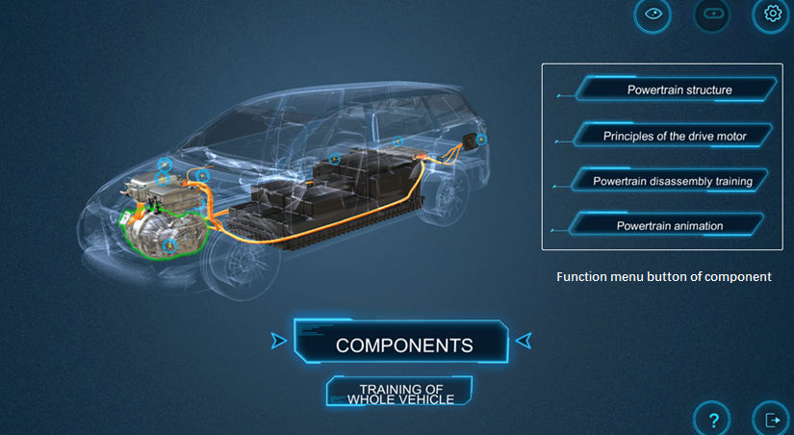
Function menu button of component

Powertrain
Click on the Powertrain model on the structure interface to show four function menu buttons of related component: Powertrain structure, Principles of the drive motor, Powertrain disassembly training, and Powertrain animation. Click on the button to enter the corresponding module.
The powertrain structure interface is as below,
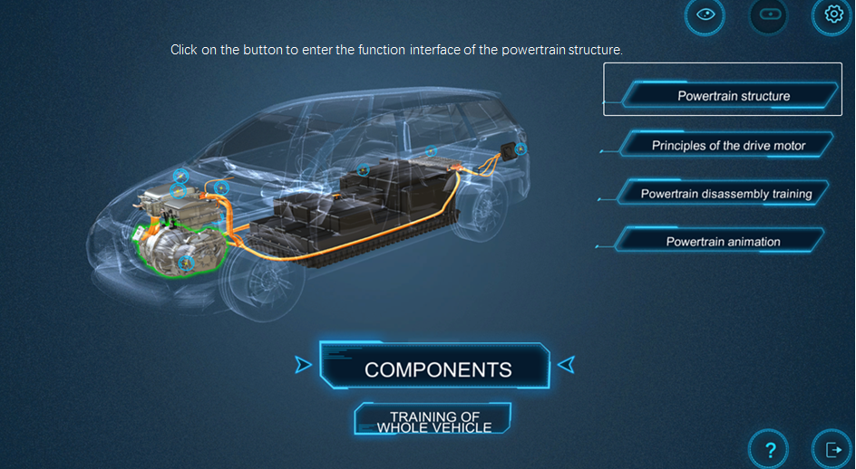
Function interface of the powertrain structure
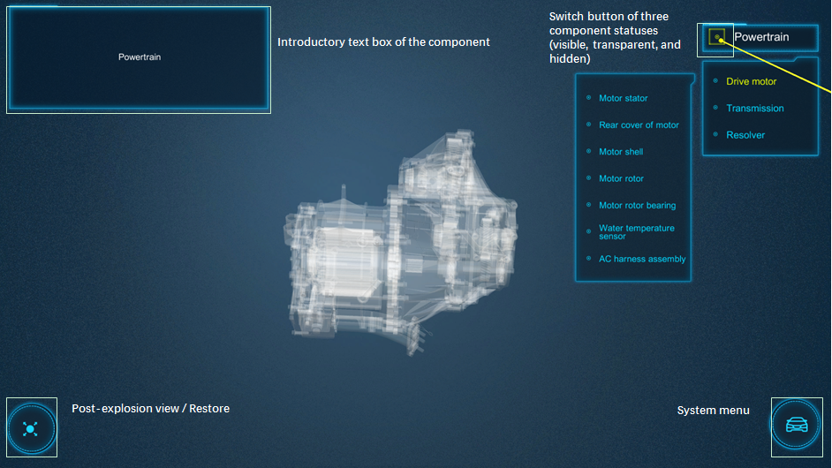
Powertrain structure
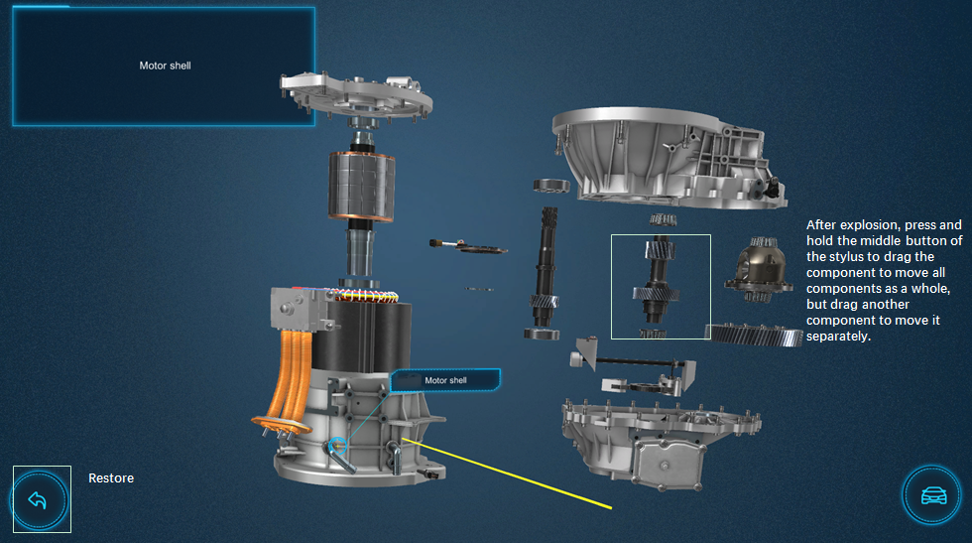
Post-explosion view
The interface of the principles of the drive motor is as below,
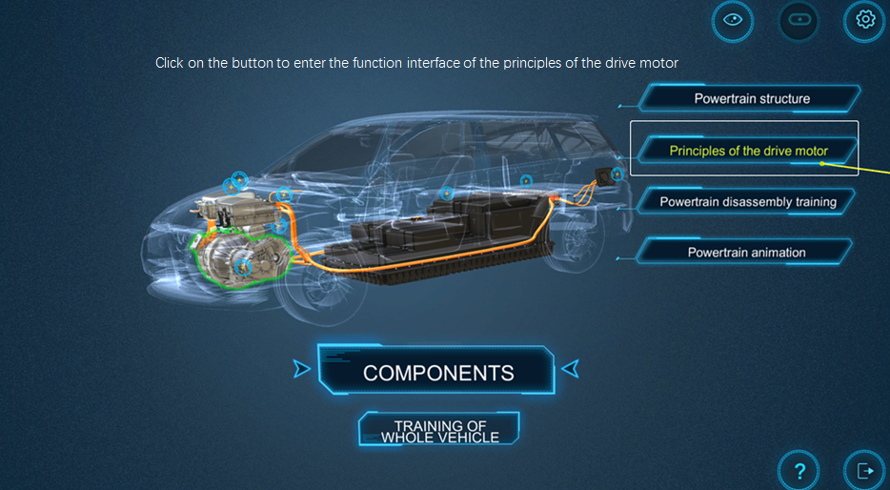
Function interface of the principles of the drive motor
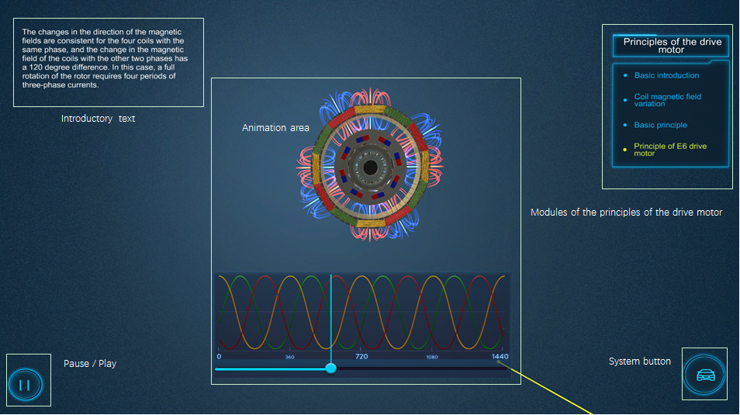
Principles of the drive motor interface
The powertrain disassembly training is as below,
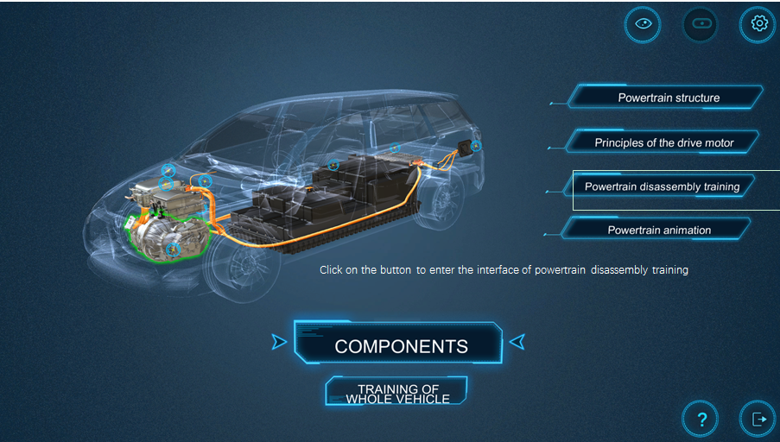
Powertrain disassembly training interface
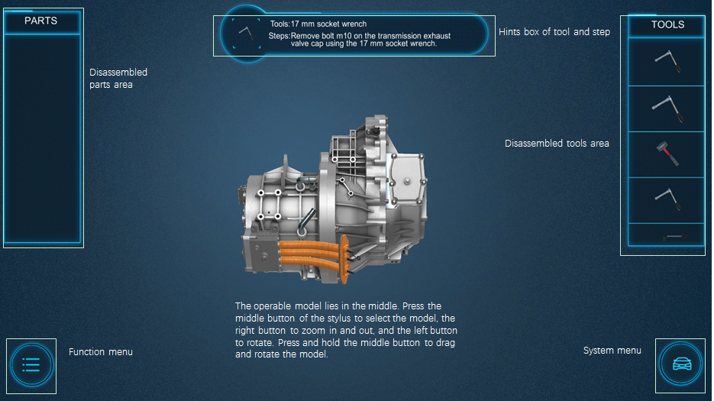
Powertrain disassembly training interface
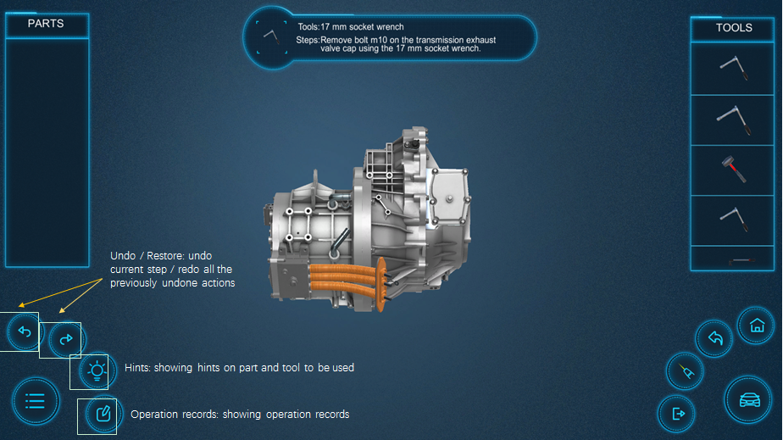
Function Menu
The powertrain animation interface is as below,
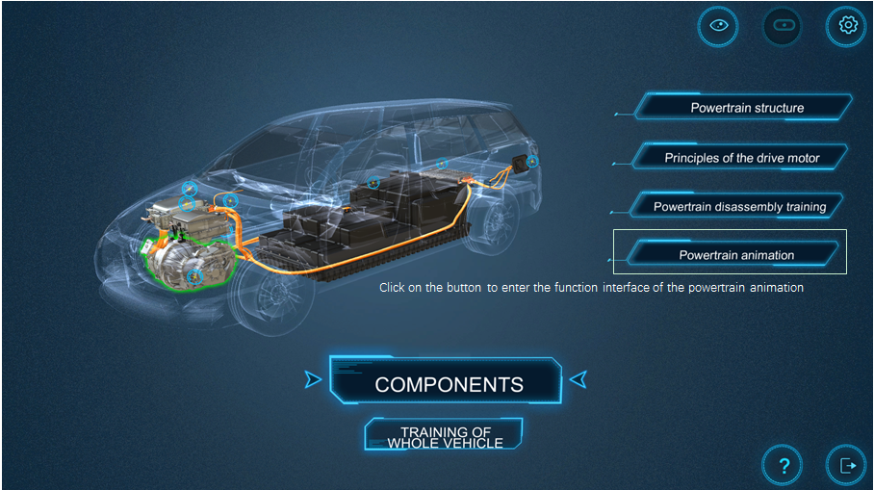
Powertrain animation interface
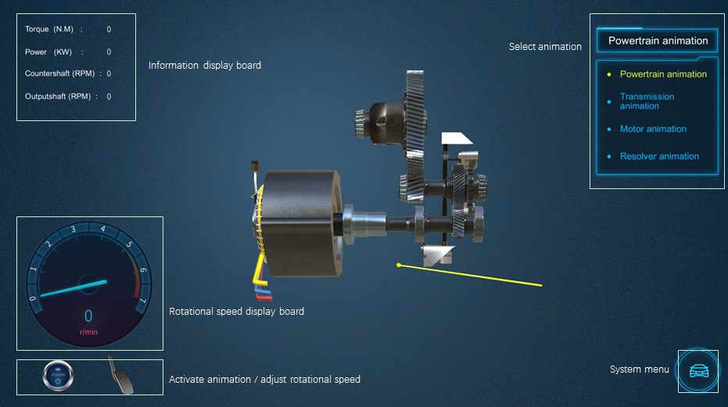
Powertrain animation interface

Power battery
Click on the pwertrain model on the structure interface to show four function menu buttons of related component: Power battery structure, Power battery principles, Power battery removal training, and Power battery installation training. Click on the button to enter the corresponding module.
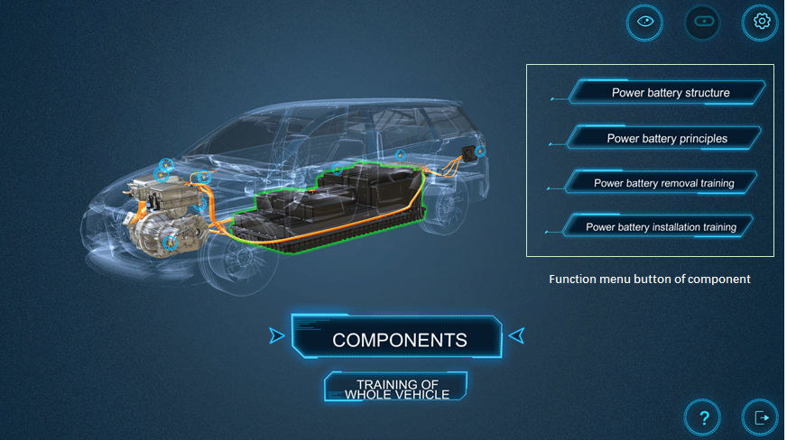
Function modules of power battery
The interfaces of the power battery structure, power battery removal training, and power battery installation training is similar to that of the powertrain. The interface of the power battery principles is as belwo,

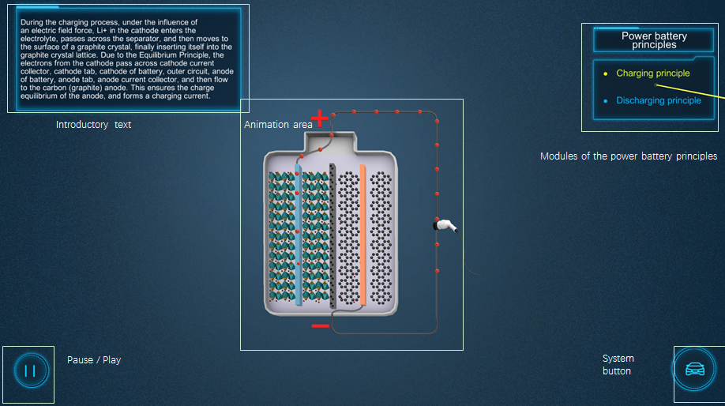
Power battery principles interface
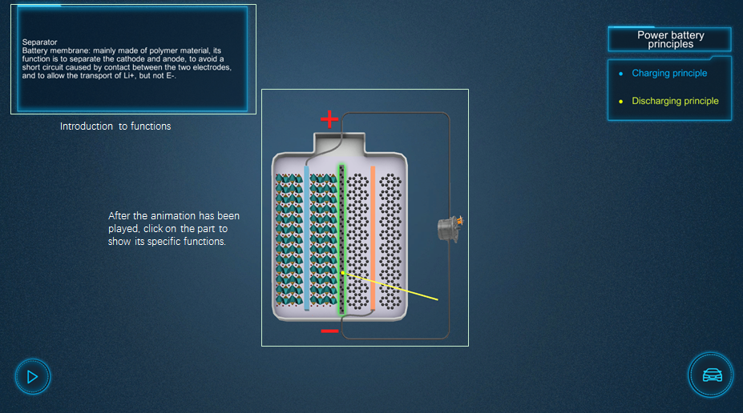
Introduction to functions of parts

Other components
As for High voltage cable, High voltage distribution box, Charging port, Motor controller, DC/DC, and Electric AC compressor, only the structure interface is available. Press the middle button of the stylus to select the component, and click the corresponding function menu to enter the structure interface.

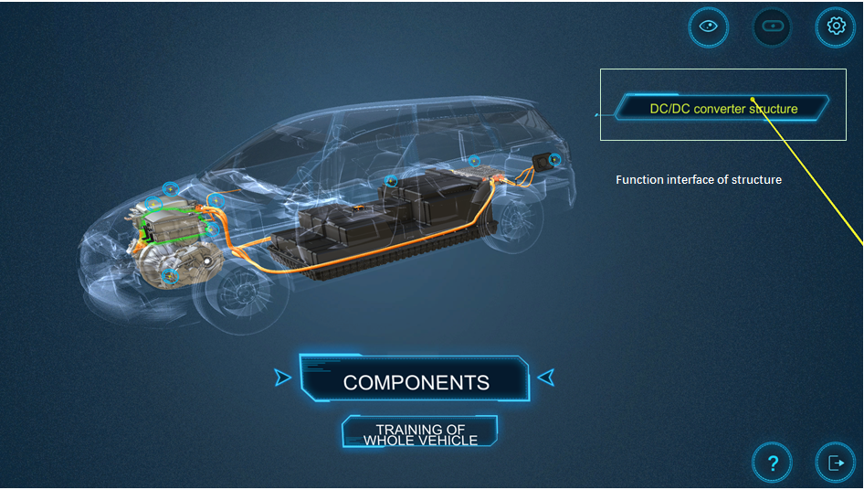
Structure interface of other components

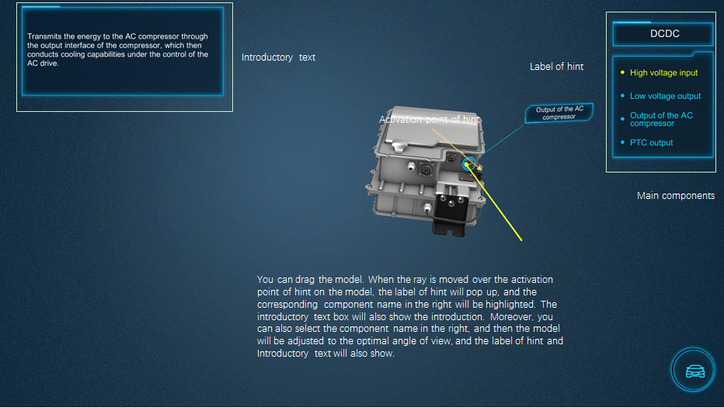
Interface of other components

Training of Whole Vehicle
Click on ‘Training of Whole Vehicle’ button on the main interface, to enter the interface of the training of Whole Vehicle. On the right, there are three buttons: High voltage safety and action rules, Failure training simulation, and Training examination. User can click on the button to enter the corresponding function interface.
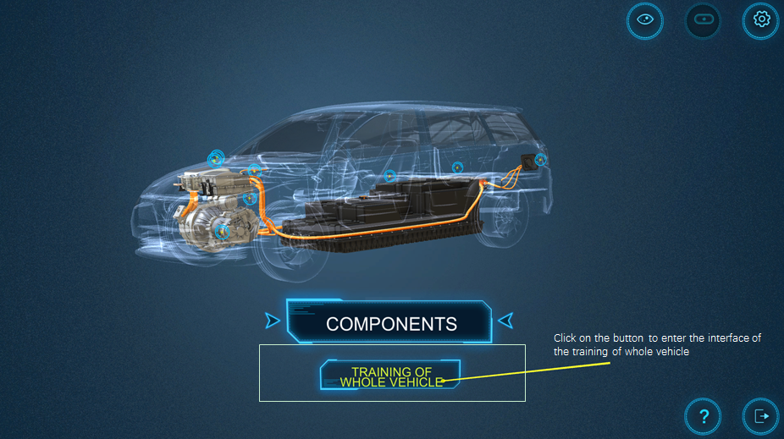
Interface of the training of whole vehicle
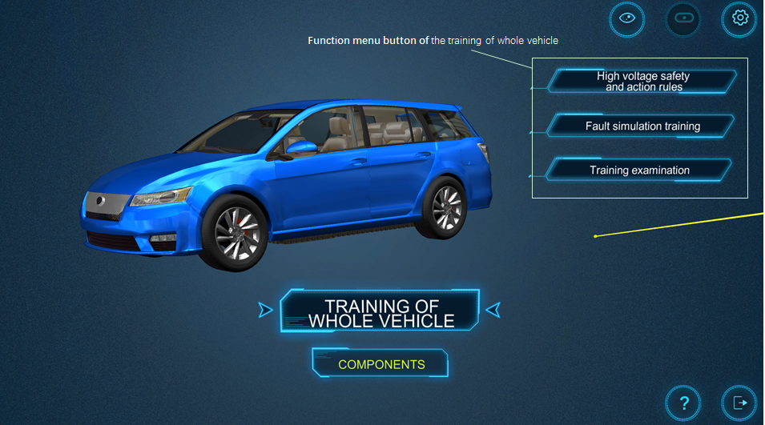

Function button of the training of whole vehicle

High voltage safety and action rules
Click on ‘High voltage safety and action rules’ button on the right to enter the interface of the high voltage safety and action rules. There are five modules: Environmental requirements, Safety requirements, Precautions, Training for charging, and Energy flow. Select the module to enter.
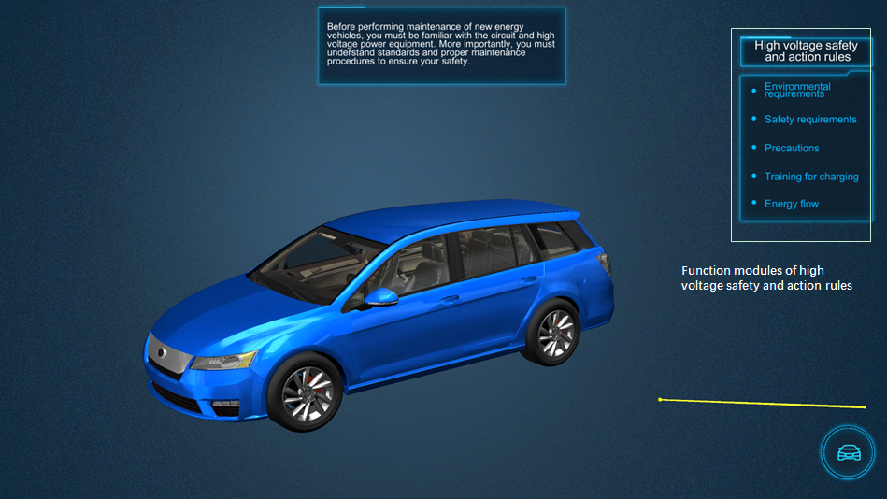
Interface of high voltage safety and action rules
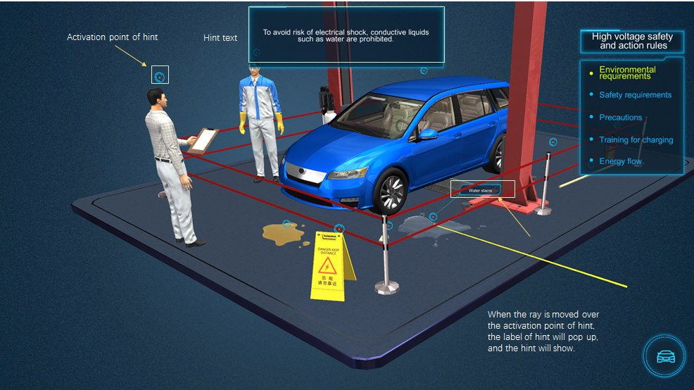
Environmental requirements
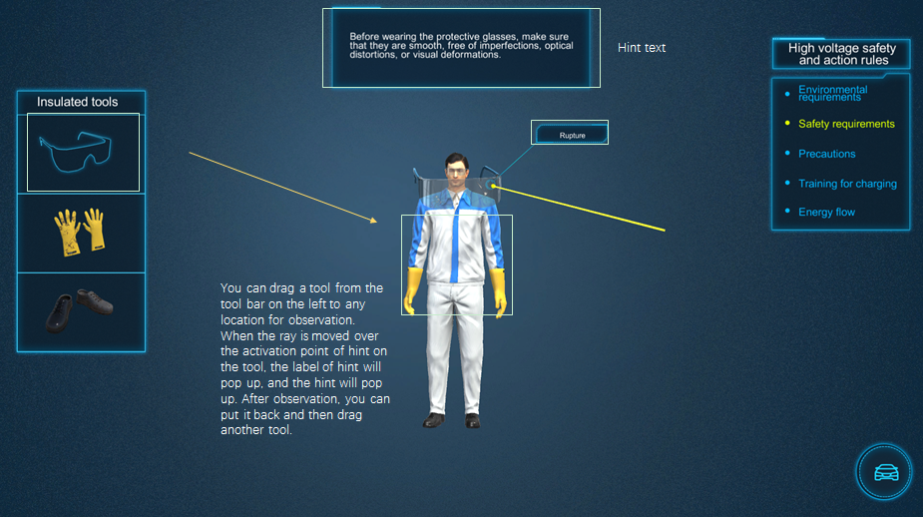
Safety requirements
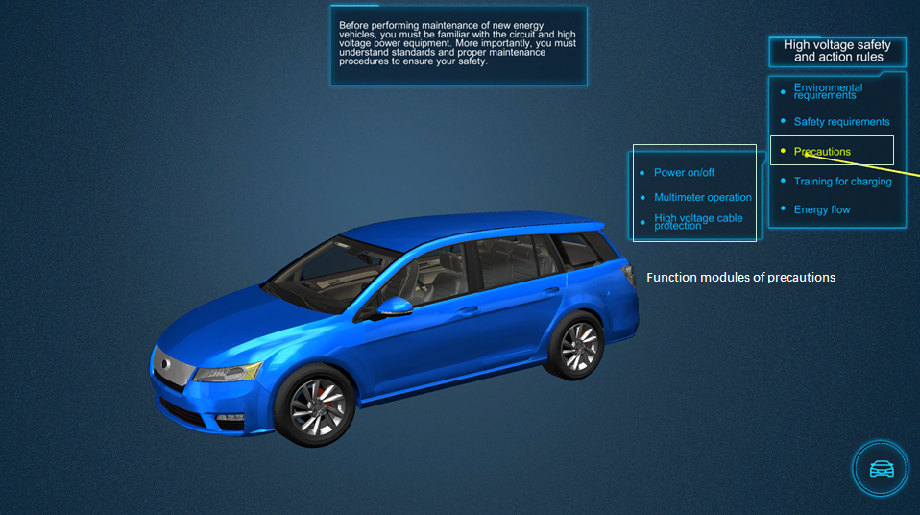
Precautions

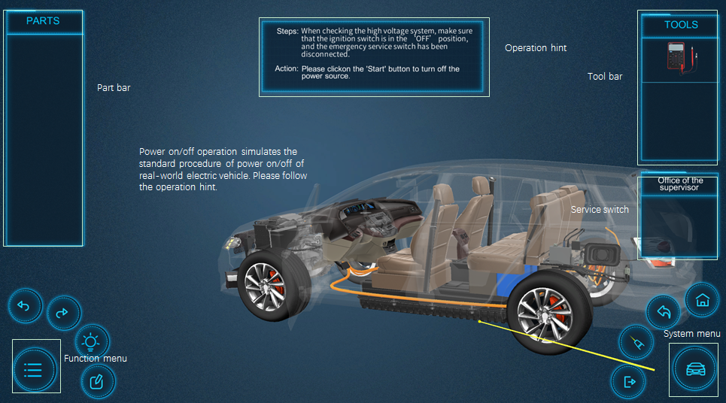
Power on/off operation
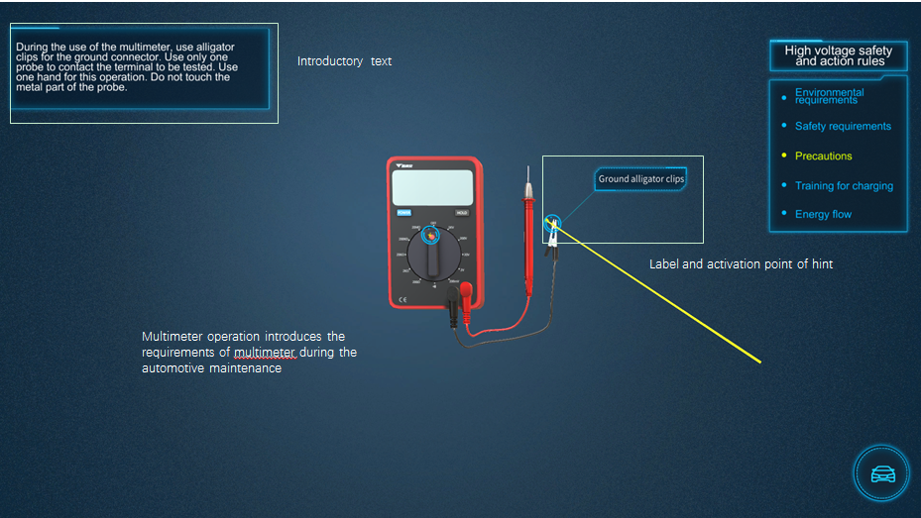
Multimeter operation
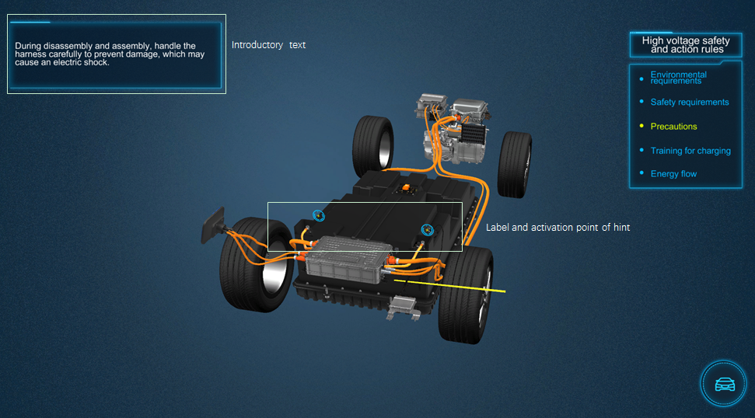
High voltage cable protection
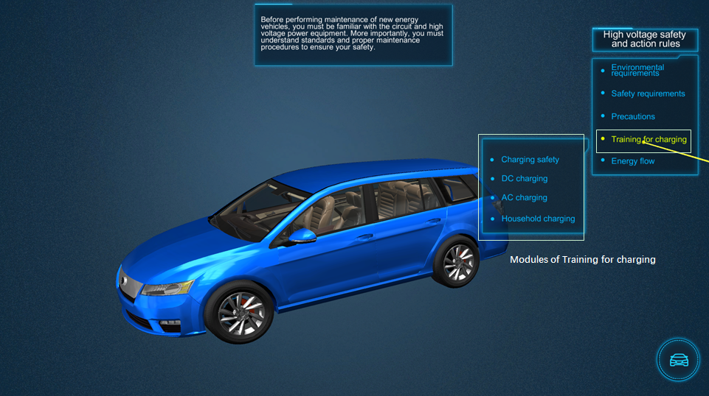
Training for charging

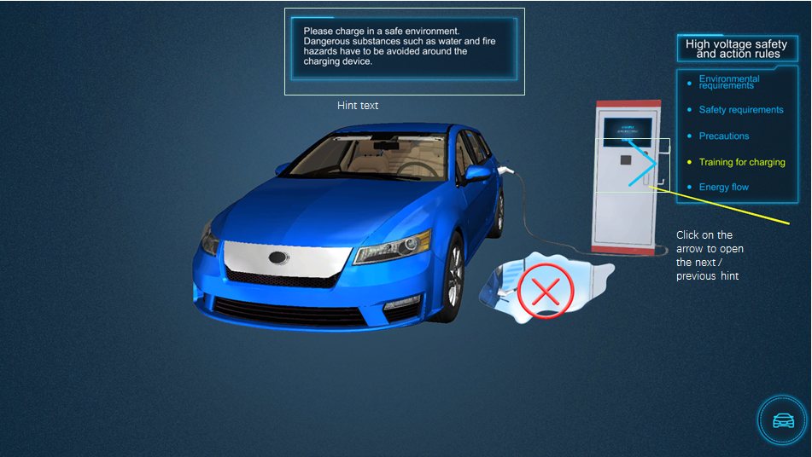
Charging Safety
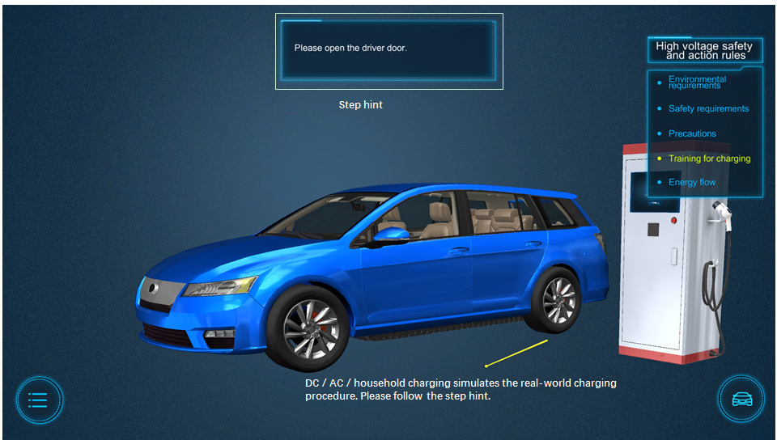
Training for DC / AC / household charging

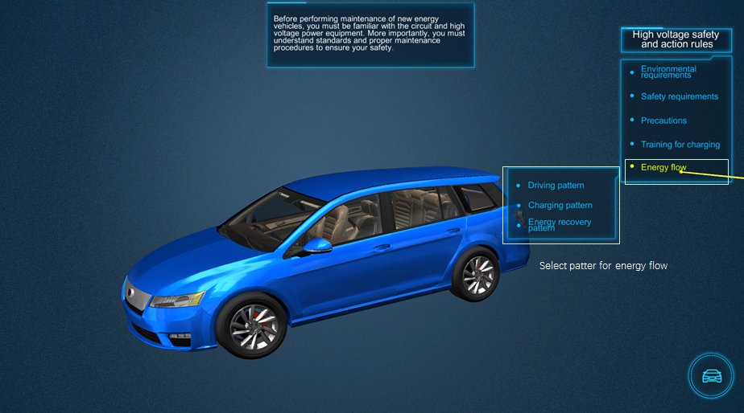
Energy flow
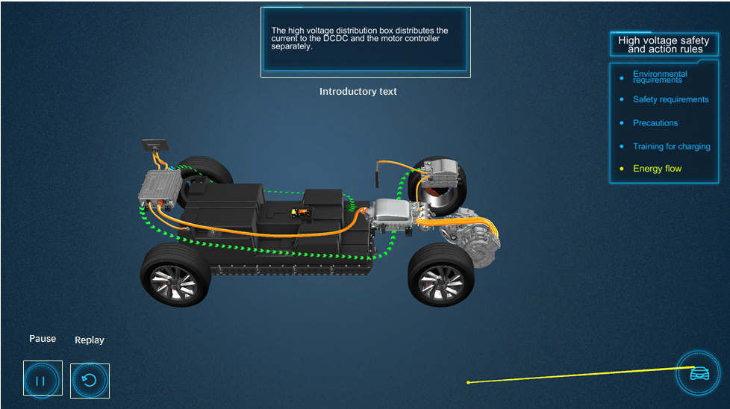
Energy flow

Failure training simulation
Click on ‘Failure training simulation’ button on the right to enter the interface of the failure training simulation. There are eleven failures in the failure list: Reduction in the power battery capacity, Blown fuse of the power battery, Fast draining of power battery, Vehicle charging failure, Nuisance tripping, Power battery alarm, Leakage in the power battery, DC/DC leakage, Leakage in the AC compressor, Leakage in the motor controller, and Leakage in the high voltage cable. Click on the name of failure to enter the corresponding training module.

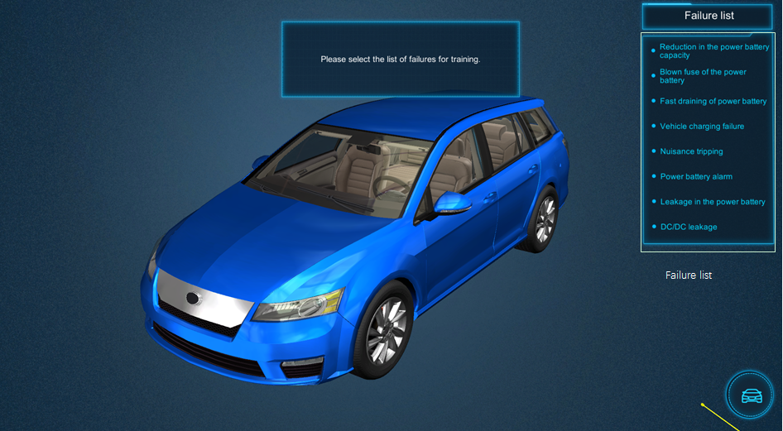
Failure training simulation interface
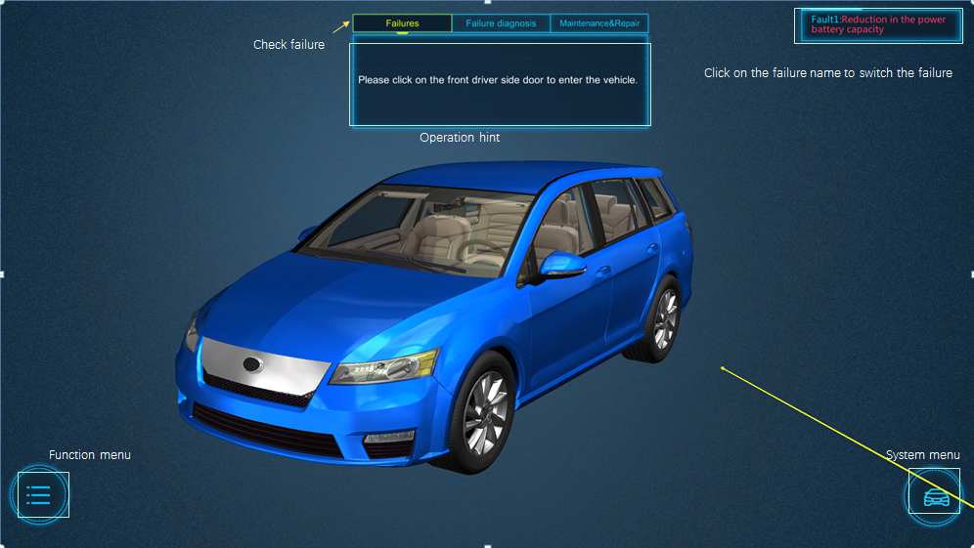
Checking failure

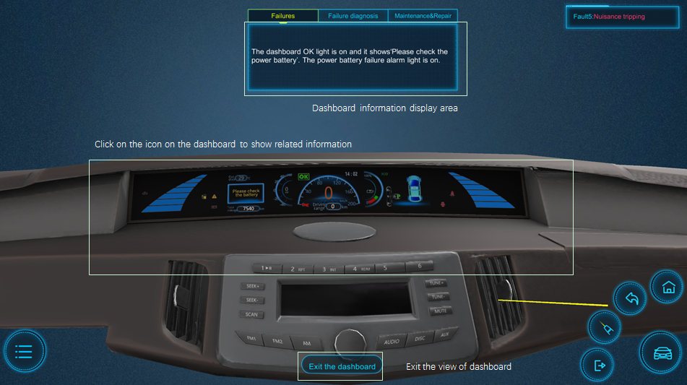
View of dashboard
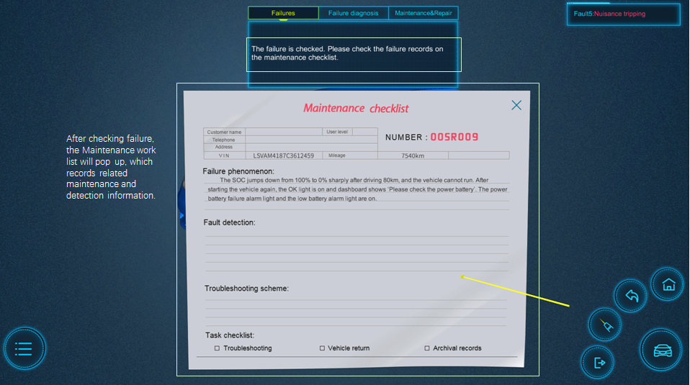
Maintenance checklist
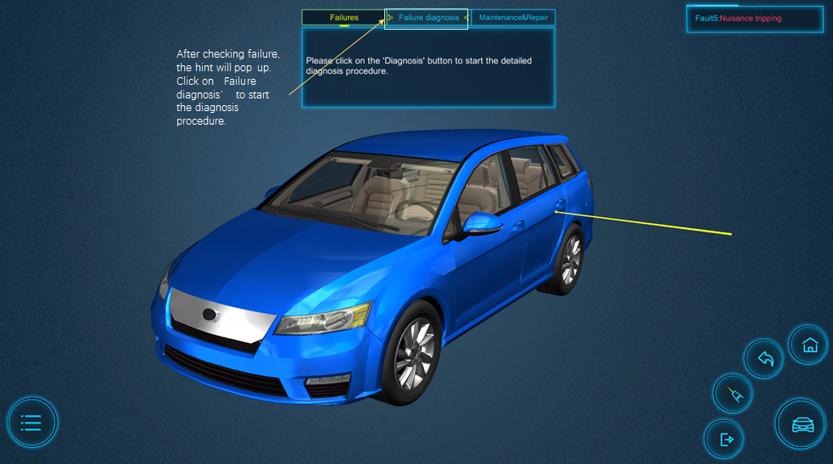
Proceed to failure diagnosis
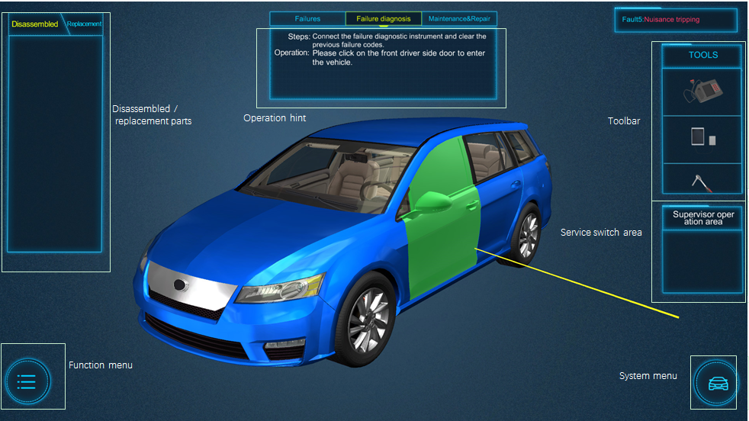
Failure diagnosis interface
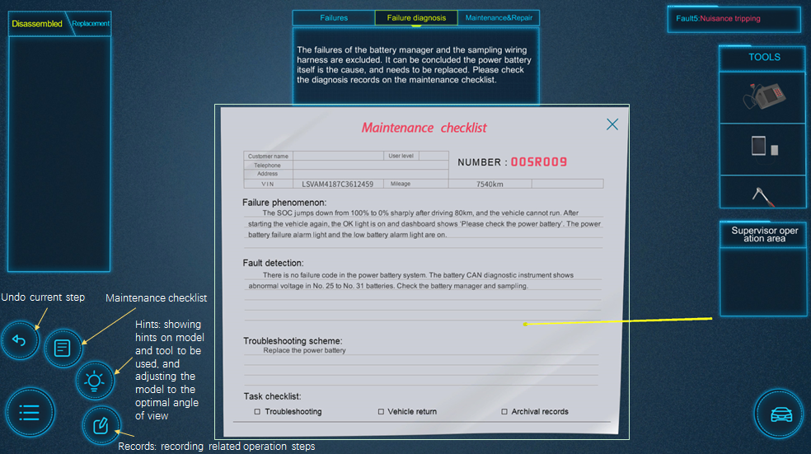
Function Menu
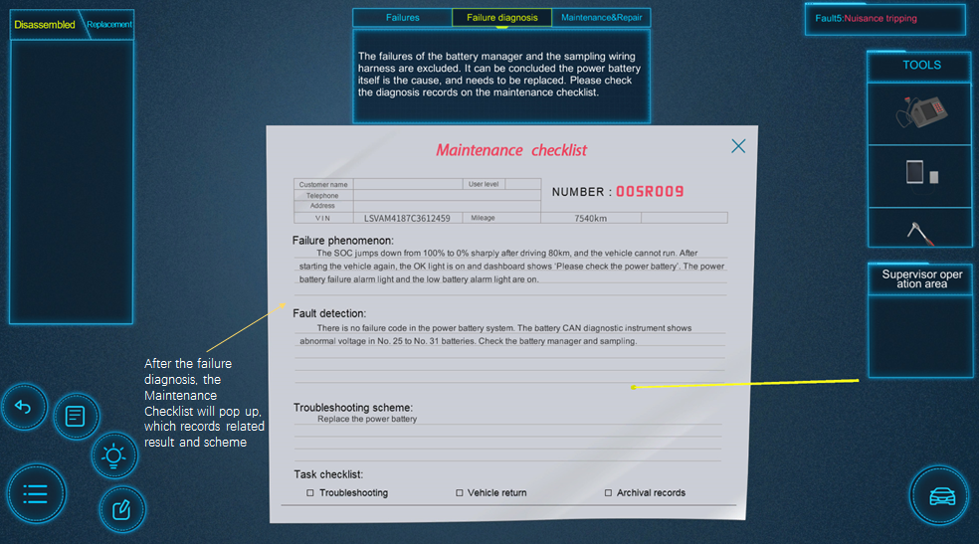
Complete the failure diagnosis
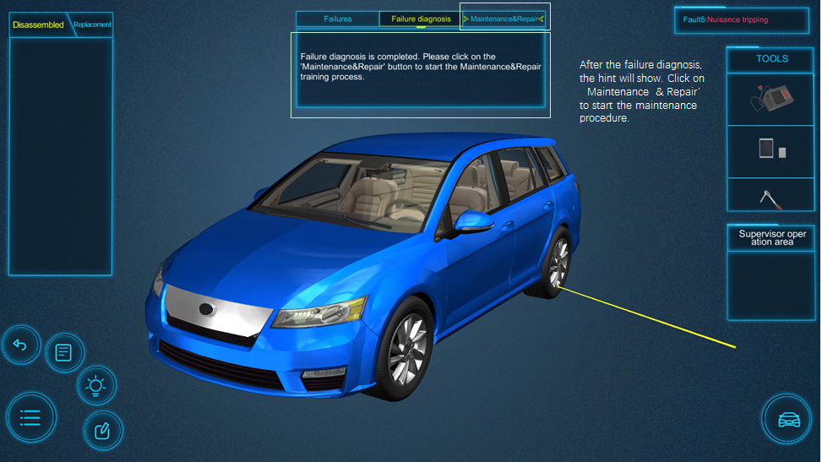

Proceed to failure diagnosis
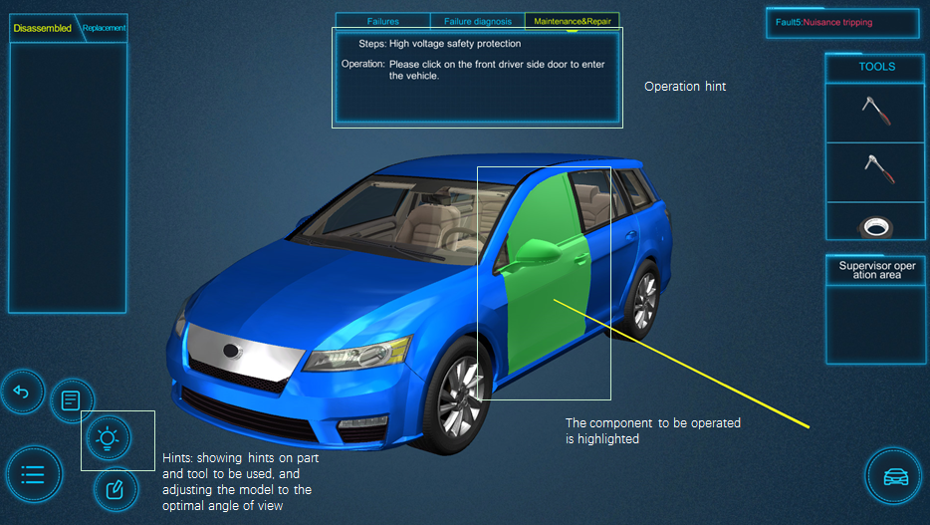
Maintenance & Repair interface

Training examination
Click on ‘Training examination’ button on the right to enter the training examination interface.
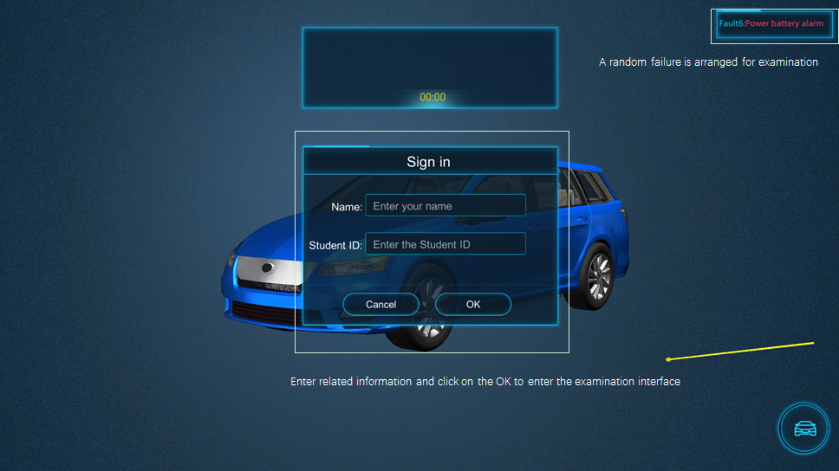
Start examination
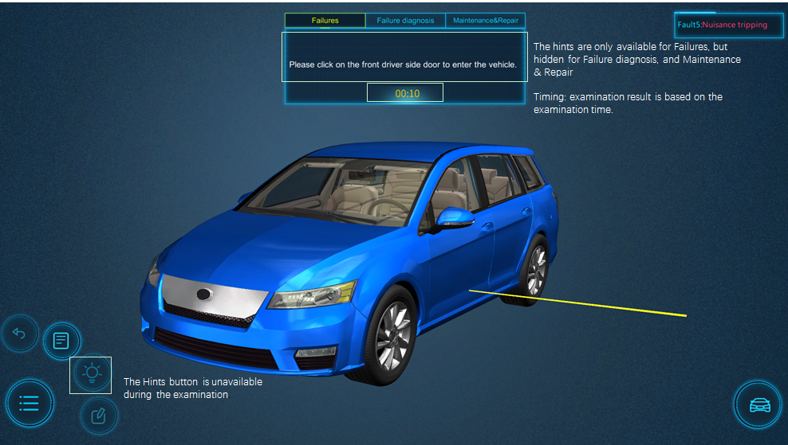
Hidden hints and timing
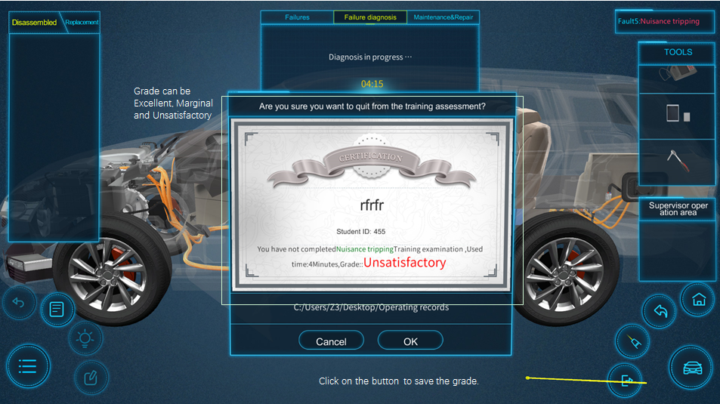
Examination grade

Application notes

In case of abnormal startup or effect, please reinstall or repair the program as below,

Click on ‘Modify’ and then ‘Next’ to complete the repair.

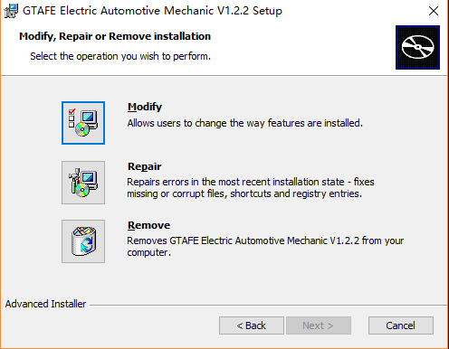

Appendix

None

